Assignment - 4

|  |  |
| --- | --- |
| Assignment Date | 20 OCTOBER 2022 |
| Student Name | HARISH S |
| Student Roll Number | 722819106030 |
| Maximum Marks | 2 Marks |

**Question-1:**

Write code and connections in wowki for ultrasonic sensor.

Whenever distance is less than 100 cms send “alert” to IBM cloud and display in

device recent events.

|  |
| --- |
| **Solution:** |
| **WOWKI LINK:** <https://wokwi.com/projects/346235465961046612> |

**#include <WiFi.h> #include <PubSubClient.h> #define TRIGGER 2**

**#define ECHO 15**

**#define sound_speed 0.034 int distance;**

**void callback(char* subscribetopic, byte* payload, unsigned int payloadLength);**

**//-------credentials of IBM Accounts------**

**#define ORG "wp72r7"**

**#define DEVICE_TYPE "iot-device-1" #define DEVICE_ID "123456789"**

**#define TOKEN "987654321"**

**String data3;**

**//-------- Customise the above values --------**

**char server[] = ORG ".messaging.internetofthings.ibmcloud.com"; char publishTopic[] = "iot-2/evt/Data/fmt/json";**

**char subscribetopic[] = "iot-2/cmd/test/fmt/String"; char authMethod[] = "use-token-auth";**

**char token[] = TOKEN;**

**//-----------------------------------------**

**WiFiClient wifiClient;**

**PubSubClient client(server, 1883, callback ,wifiClient); void setup()**

**{**

**Serial.begin(115200); pinMode(TRIGGER, OUTPUT); pinMode(ECHO, INPUT); delay(10);**

**Serial.println(); wificonnect(); mqttconnect();**

**}**

**void loop()**

**{**

**digitalWrite(TRIGGER, HIGH); delayMicroseconds(10); digitalWrite(TRIGGER, LOW);**

**int duration=pulseIn(ECHO,HIGH); distance=(duration*sound_speed)/2; Serial.print("Distance:"); Serial.print(distance); Serial.println("cms"); if(distance<100){ PublishData(distance);**

**}**

**delay(1000);**

**if (!client.loop()) { mqttconnect();**

**}**

**}**

**void PublishData(int d) { mqttconnect();**

**String payload = "{\"message\":alert}";**

**Serial.print("Sending payload: "); Serial.println(payload);**

**if (client.publish(publishTopic, (char*) payload.c_str())) { Serial.println("Publish ok");**

**} else {**

**Serial.println("Publish failed");**

**}**

**}**

**void mqttconnect() {**

**if (!client.connected()) { Serial.print("Reconnecting client to "); Serial.println(server);**

**while (!!!client.connect(clientId, authMethod, token)) { Serial.print(".");**

**delay(500);**

**}**

**initManagedDevice(); Serial.println();**

**}**

**}**

**void wificonnect()**

**{**

**Serial.println(); Serial.print("Connecting to ");**

**WiFi.begin("Wokwi-GUEST", "", 6);**

**while (WiFi.status() != WL_CONNECTED) { delay(500);**

**Serial.print(".");**

**Serial.println(""); Serial.println("WiFi connected"); Serial.println("IP address: "); Serial.println(WiFi.localIP());**

**}**

**void initManagedDevice() {**

**if (client.subscribe(subscribetopic)) { Serial.println((subscribetopic)); Serial.println("subscribe to cmd OK");**

**} else {**

**Serial.println("subscribe to cmd FAILED");**

**}**

**}**

**void callback(char* subscribetopic, byte* payload, unsigned int payloadLength)**

**{**

**Serial.print("callback invoked for topic: "); Serial.println(subscribetopic);**

**for (int i = 0; i < payloadLength; i++) { data3 += (char)payload[i];**

**}**

**Serial.println("data: "+ data3); data3="";**

**}**

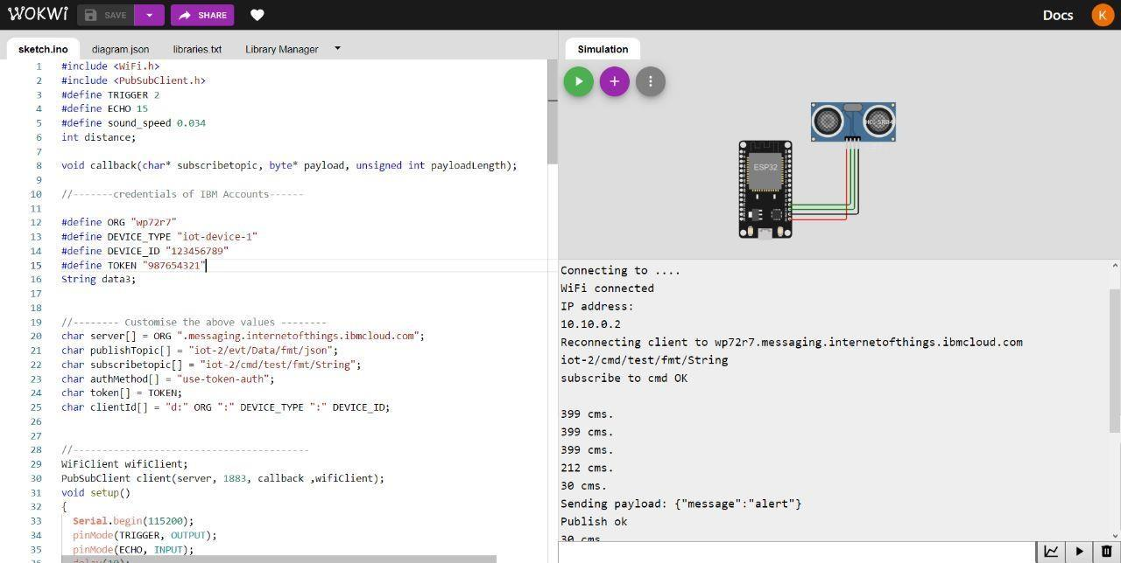

**IBM CLOUD RECENT EVENTS:**

